Eternal God, whose steadfast love for us
is from everlasting to everlasting.
We give you thanks for cherished memories
and commend one another into your care
as we move in new directions.
Keep us one in your love forever,
through Jesus Christ our Lord, Prince of Peace,
Healer of our brokenness, Hope of the world. Amen.

* Hymn: “Lead Me Lord” UMH #473

This week’s questions to ponder: To what is God calling me? How might others know that I walk in the Spirit with Christ?
Morning Prayer
Almighty God, in awe I remember that you made me in your image and breathed the Spirit of life into me. I marvel that your Son, Jesus, gave himself for my salvation. Help me to live this day fully open to your presence. Let me worship you alone with my body, mind, and spirit, delighting in what is good and turning from what is not. Let me love my neighbor as myself with all that you give me. Be patient with me and help me to be patient with others. Teach me how to bring peace to those who are troubled and to show kindness, especially to the weak. Today, let me seek your kingdom, through Jesus Christ, my Lord. Amen.
Evening Prayer
O God, thank you for your care today. As I move into evening, help me to recall with thanksgiving the wonders I have known, the joy I have felt, and your love I have received. Forgive me for the ways in which I misused what you intend for good. Grant the peace of sleep to all who are weary; and let us rise to a new day, giving you praise. Through Jesus Christ, Amen.
Geyers United Methodist Church
1605 Geyers Church Road
Middletown, PA 17057

Pastor Amy Raser
Cell Phone: (814) 932-9258
Email: araser@susumc.org

Office Phone: (717) 944-6426
Email: geyerschurch@verizon.net
Website: www.geyersumc.org
Come, Let Us Worship Together!

June 26, 2022

Geyers United Methodist Church

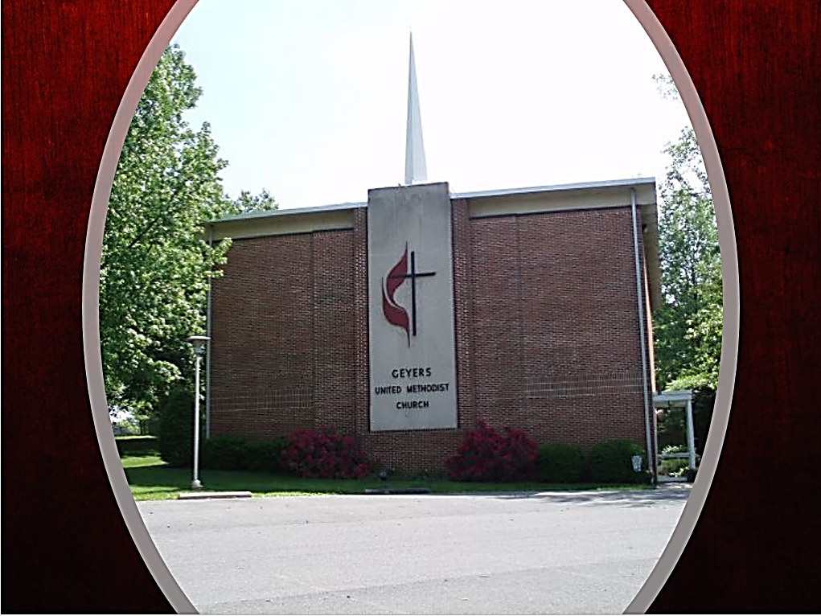
Come, Let Us Worship Together!

June 26, 2022

Geyers United Methodist Church

Geyers United Methodist Church
3rd Sunday After Pentecost
June 26, 2022

The Gathering
Musical Prelude Becky Keefer

Lighting of the Altar Candles

Greeting and Announcements

*Call to Worship:
We gather here today to praise God
for God’s mighty acts in our lives.
There are many people
who do not believe in God’s presence.
We are called to learn of God’s love and power.
We are called to proclaim God’s transforming love
to all people.
Let us open our hearts, souls, and spirits as we
God’s word and worship our Lord in prayer and song.

*Hymn “Sweet, Sweet Spirit” UMH #334

Gathering Prayer:
Lord, we want to follow you wherever you lead.
Reach out to us this day, stirring our souls and spirits
with the winds of your power
that we may faithfully be your disciples.
For we ask this in Jesus’ Name. Amen.

Words of Assurance:
The crucified Christ has set us free to live in the Spirit of life.
Hear the good news of the gospel.
In Jesus Christ, we are forgiven.
Praise God for God’s grace filled love. Amen.

Let’s Talk A Time with the Kids Pastor Steve
Prayers of the People and the Lord’s Prayer

Proclamation and Response
Scripture: Philippians 1:3-11
Meditation: “Grateful for You” Pastor Steve
Hymn: “Turn Your Eyes Upon Jesus” UMH #349

Meditation: “Let Me Say It One More Time” Pastor Karen

God Loves You
Scriptures: Jeremiah 31:3, John 3:16,17
Hymn: “Jesus Loves Me This I Know” UMH #191(vs 1&3)

Christianity Is Not a Religion. It is a Relationship
Scripture: “The Main Thing” Luke 10:27
Hymn: “The Summons” FWS #2130

Our Faith is Personal, But Never Meant to Be Private
Scripture John 13:34 & Matthew 25:24-40
Hymn: “They’ll Know We Are Christians By Our Love” FWS #2223

We Are On the Journey By and With God’s Grace

*Sending Forth
We thank you, the members and friends of Geyers U.M. Church,
for the love and support you have shown us
while we have ministered among you.
We are grateful for the ways our leadership has been accepted.
We ask forgiveness for the mistakes we have made.
As we leave, we carry with us all the blessings
we have received here.

We receive your thankfulness, offer forgiveness,
and accept that you now leave to retire.
We express our gratitude for your time among us.
We ask your forgiveness for our mistakes.
Your influence on our faith and faithfulness
will not leave with your departure.

We accept your gratitude and forgiveness,
and we forgive you, trusting that our time together
and our parting are pleasing to God.
We release you from turning to us and depending on us.
We encourage your continuing ministry here
and will pray for you and for Pastor Amy.
(Continued on back)

*Please stand as you are able.”

